Activity A
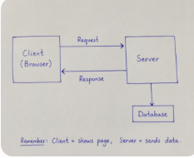

Activity B
URL:
https://www.google.com:443/search?q=shoes#results

. Protocol: https
- Host: www.google.com
- Port: 443
- Path: /search
- Query: ?q=shoes
- Fragment: #results
Change the search
Pehle:
https://www.google.com:443/search?q=shoes#results

Phir Google par laptops search karo:
https://www.google.com:443/search?q=laptops#results

Changed part: Query
?q=shoes → ?q=laptops

Activity C:
- Find one status code from each family:
  - 2xx → Success
  - 3xx → Redirection
  - 4xx → Client Error
  - 5xx → Server Error

2xx → Success

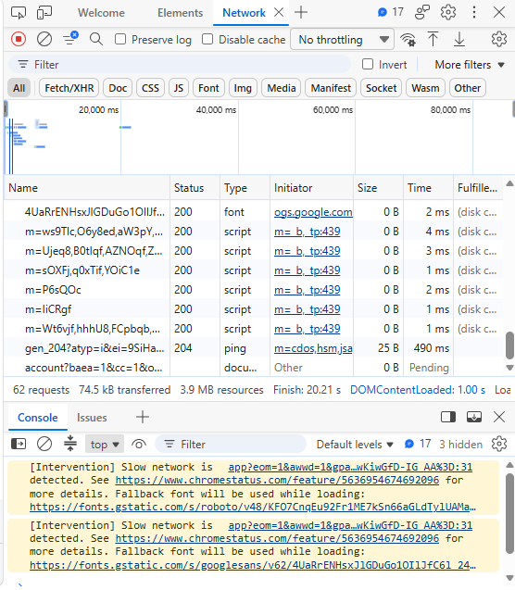

  - 3xx → Redirection

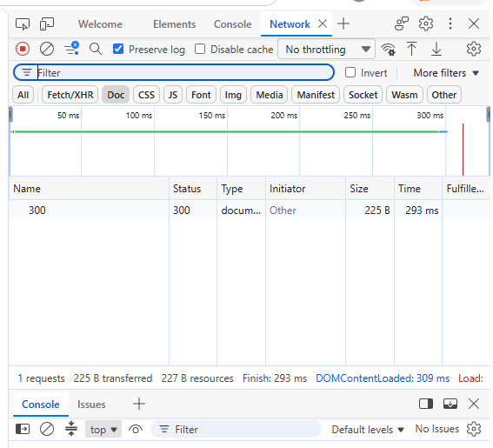

  - 4xx → Client Error

  - 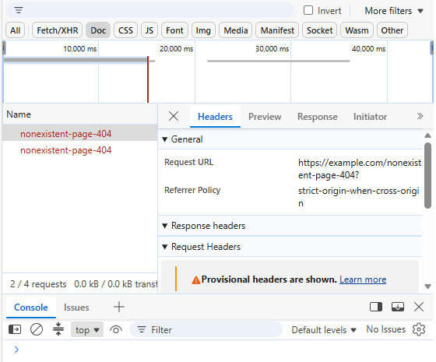

  - 5xx → Server Error

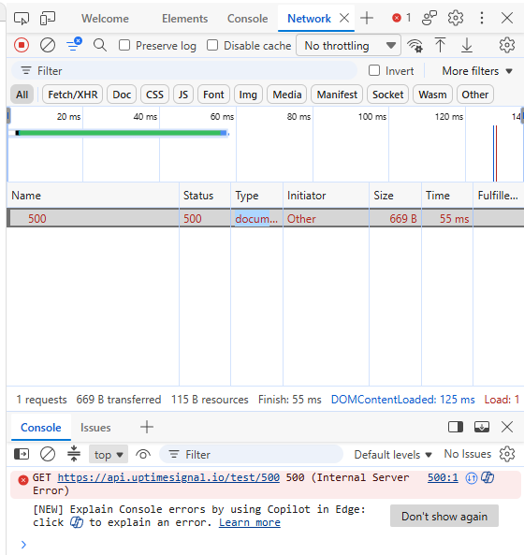

Activity D: Tools Installation & Setup Activity
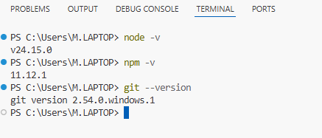

Activity E: personalise and serve

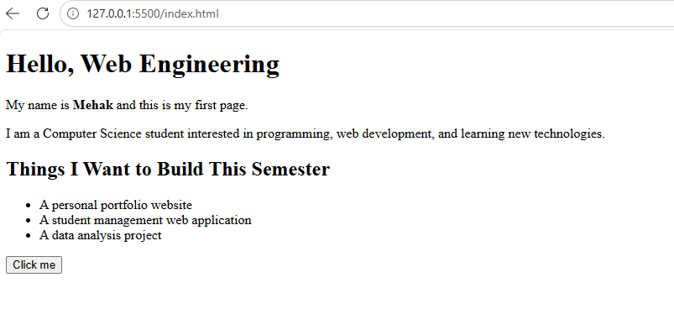

Activity F:
Network: reload. Find
index.html
. Confirm status
200

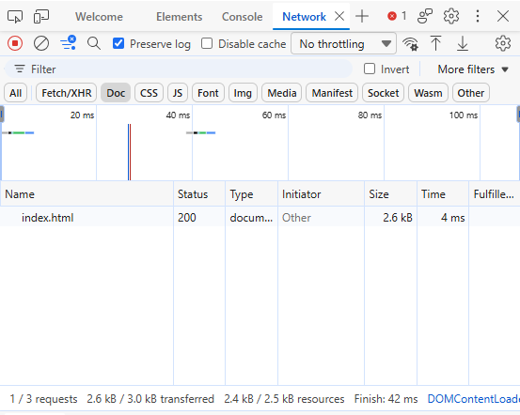
The Elements edit disappeared because DevTools changes are temporary and are not saved to the HTML file.”

One deliberate Console error explained in one sentence
The error happened because I tried to call a function that does not exist.
Task 1:



Task 2
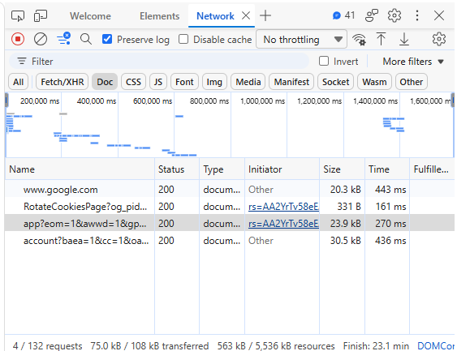
Number of requests: 4
Largest file: account?baea=1&cc=... — HTML document

